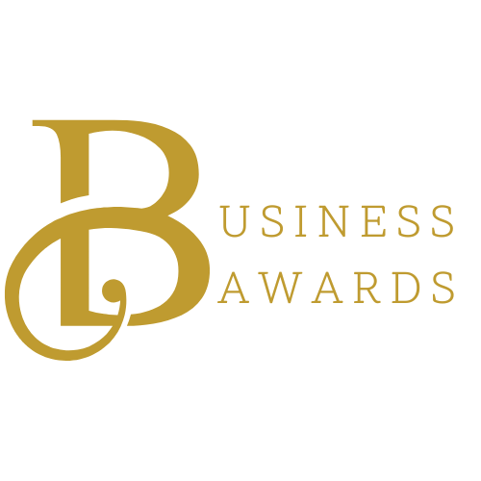
Business Awards Categories & Criteria

To be considered for a business award, nominees must meet the following requirements:
- Be a current Prince William Chamber member in good standing.
- Demonstrate ongoing business stability and viability.
- Maintain an excellent reputation within the community.
- Businesses that previously received an award in a specific category are ineligible for the same category for three years following their win. They may still be nominated in other categories.
- Submit nominations by 5:00 pm on January 7th, 2026.

NOTE: Please only nominate a business for a category one time. Businesses may be nominated for multiple categories.

2026 Business Awards Categories
Excellence in Business
- Excellence in Business (1-10 Employees)
- Excellence in Business (11-50 Employees)
- Excellence in Business (51+ Employees)
Criteria: Awarded to a member business with exceptional contributions to the Chamber and/or business community. Please detail the business's contributions, growth, success stories, or notable achievements on the nomination form. (Specify the number of employees in the nominated business when submitting.)

Emerging Business of the Year
Criteria: Awarded to a business operating for three years or less that has demonstrated outstanding contributions to the Chamber and the local community. The number of employees is not a factor for this award.

Innovative Partnership of the Year
Criteria: Recognizes a member business, not-for-profit organization, or government entity that has shown vision and created groundbreaking solutions in the past year. This award may honor green practices, the establishment of unique partnerships, or a business’s innovative practice during the 2025 business year.

Community Outreach Award
- Community Outreach Award (1-10 Employees)
- Community Outreach Award (11+ Employees)
Criteria: Awarded to any Chamber member for exemplary support of the community and not-for-profit organizations, demonstrated through volunteer hours, in-kind goods and services, philanthropic contributions, and corporate policies promoting community involvement. Note: 501(c)(3) organizations are excluded and should apply for the Agnes L. Colgan Community Service Awards instead.

Minority Owned Business of the Year
Criteria: Awarded to a minority-owned business, as defined by federal guidelines, that has shown a strong commitment to community impact, innovation, and sustainable growth within Prince William County.

Veteran Owned Business of the Year
Criteria: Honors a veteran-owned member business for its outstanding contributions to the Chamber and/or business community. Please highlight contributions, growth, success stories, or achievements on the nomination form.

All eligible nominees will be entered in the People’s Choice Award, to include the Agnes L. Colgan nominees who are Chamber members. The People’s Choice Award is the only award selected by a popularity vote sent out to the full Chamber Membership.
2026 Industry Awards
Agnes L. Colgan Community Service Awards
- Agnes L. Colgan Community Service Award: Arts & Education
- Agnes L. Colgan Community Service Award: Health & Human Services
Criteria: Awarded to two 501(c)(3) organizations that have made a significant positive impact on the quality of life in the Greater Prince William region. Each recipient will receive a $1,000 award to support their ongoing work.
Eligibility: Nominees do not need to be Chamber members to qualify for this award.
(All Charles J. Colgan Visionary Award Nominations are submitted by the Prince William Chamber of Commerce Board of Directors.)

